Multifaster 6 lines: Male plate - 6 housings 1/2". |  | Application  
MF-P608 M-005092-M
4
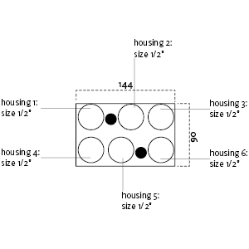

Technical Specifications (Stainless Steel)
Size |  |  | Working Pressure |  | Flow Rate | Spillage | Burst pressure (MPa & psi)
dash | mm | inch | (MPa) | (psi) | (l/min) | (ml) | Male |  | Female |  | Male + Female
08 | 12,5 | 1/2 ‘’ | 25 | 3626 | 70 | 0,01 | 100 | 14504 | 100 | 14504 | 100 | 14504

Materials | ; Stainless steel  Aluminium; Steel |  | Valve Type | Flat
Seals | VITON |  | Connection | Lever
Working temperatures | -22°C to 200°C  -4 F° to 392 F° |  | Disconnection | Lever
Surface treatment | CARBON STEEL (CRlll); Paint |  | Connection Under Pressure | Not allowed for Stainless steel

Mobile Plate
 |  | Housing  size |  | Thread  Type |  | Thread  Standard |  | Thread  size |  | Component  Type
Hou.1 | 1/2” |  | --/ BSP |  | BSP FEMALE |  | 1/2" |  | Coupling
Hou.2 | 1/2” |  | --/ BSP |  | BSP FEMALE |  | 1/2" |  | Coupling
Hou.3 | 1/2” |  | --/ BSP |  | BSP FEMALE |  | 1/2" |  | Coupling
Hou.4 | 1/2” |  | --/ BSP |  | BSP FEMALE |  | 1/2" |  | Coupling
Hou.5 | 1/2” |  | --/ BSP |  | BSP FEMALE |  | 1/2" |  | Coupling
Hou.6 | 1/2” |  | --/ BSP |  | BSP FEMALE |  | 1/2" |  | Coupling

Thread chart
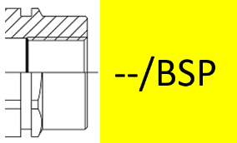

Couplings spare parts Plate spare parts
 | Housing  size | Spare  Part code
Component |  | Spare  Part code
Male plate | KIT VP8 (SCREWS), KIT GP4 (PINS)

Hou.1 |  | 1/2” |  | KIT2FNP12G M2V
Hou.2 |  | 1/2” |  | KIT2FNP12G M2V
Hou.3 | 1/2” |  | KIT2FNP12G M2V
Hou.4 |  | 1/2” |  | KIT2FNP12G M2V
Hou.5 |  | 1/2” |  | KIT2FNP12G M2V
Hou.6 |  | 1/2” |  | KIT2FNP12G M2V

