Multifaster 6 lines: Male plate - 2 housings 1/2" - 4 housings 3/4"'. |  | Application
MF-P6I M-006120-M
4
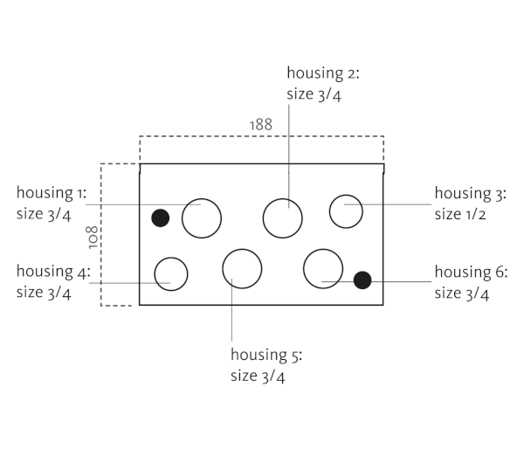

Technical Specifications
Size |  |  | Working Pressure |  | Flow Rate | Spillage | Burst pressure (MPa & psi)
dash | mm | inch | (MPa) | (psi) | (l/min) | (ml) | Male |  | Female |  | Male + Female
12 | 20 | 3/4 ‘’ | 25 | 3626 | 105 | 0,02 | 100 | 14504 | 100 | 14504 | 100 | 14504

Materials | Aluminium; Steel |  | Valve Type | Flat
Seals |  |  | Connection | Lever
Working temperatures | -25°C to 100°C  -13 F° to 212 F° |  | Disconnection | Lever
Surface treatment | CARBON STEEL (CRlll); Paint |  | Connection Under Pressure

Mobile Plate
 |  | Housing  size |  | Thread  Type |  | Thread  Standard |  | Thread  size |  | Component  Type
Hou.1 | 3/4” |  |  |  |  |  |  |  | Plug
Hou.2 | 3/4” |  | --/ BSP |  | BSP FEMALE |  | 3/4" |  | Coupling
Hou.3 | 1/2” |  |  |  |  |  |  |  | Electrical connector |  | 3 PINS, rated current: 13 A
Hou.4 | 1/2” |  |  |  |  |  |  |  | Electrical connector |  | 3 PINS, rated current: 13 A
Hou.5 | 3/4” |  | --/ BSP |  | BSP FEMALE |  | 3/4" |  | Coupling
Hou.6 | 3/4” |  | --/ BSP |  | BSP FEMALE |  | 3/4" |  | Coupling


Please, note that this is a configuration Faster does not recommend.
This selection might cause an unbalanced hydraulic load.
Thread chart
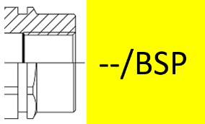

Couplings spare parts Plate spare parts
 | Housing  size | Spare  Part code
Component |  | Spare  Part code
Male plate | KIT VP8 (SCREWS), KIT GP8 (PINS)

Hou.1 |  | 3/4” |  | KIT TSP 34 M
Hou.2 |  | 3/4” |  | KIT3FNP34GAS M
Hou.3 | 1/2” |  | KIT SPEL08-3M
Hou.4 |  | 1/2” |  | KIT SPEL08-3M
Hou.5 |  | 3/4” |  | KIT3FNP34GAS M
Hou.6 |  | 3/4” |  | KIT3FNP34GAS M

