Multifaster 6 lines: Female plate - 6 housings 1/2". |  | Application  
MF-P608 F-006112-F
4
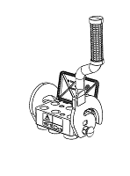 | 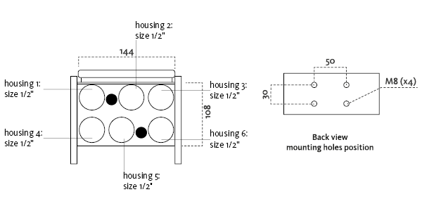
Technical Specifications
Size |  |  | Working Pressure |  | Flow Rate | Spillage | Burst pressure (MPa & psi)
dash | mm | inch | (MPa) | (psi) | (l/min) | (ml) | Male |  | Female |  | Male + Female
08 | 12,5 | 1/2 ‘’ | 25 | 3626 | 70 | 0,01 | 100 | 14504 | 100 | 14504 | 100 | 14504

Materials | Aluminium; Steel |  | Valve Type | Flat
Seals |  |  | Connection | Lever
Working temperatures | -25°C to 100°C  -13 F° to 212 F° |  | Disconnection | Lever
Surface treatment | CARBON STEEL (CRlll); Paint |  | Connection Under Pressure

Fixed Plate
Lever Type: Right "S" lever, right safety lock, lift to close
 |  | Housing  size |  | Thread  Type |  | Thread  Standard |  | Thread  size |  | Component  Type
Hou.1 | 1/2” |  | 2/ METRIC |  | METRIC "L" MALE |  | 30x2 |  | Coupling
Hou.2 | 1/2” |  |  |  |  |  |  |  | Empty
Hou.3 | 1/2” |  | 2/ METRIC |  | METRIC "L" MALE |  | 16x1.5 |  | Coupling
Hou.4 | 1/2” |  | 2/ METRIC |  | METRIC "L" MALE |  | 18x1.5 |  | Coupling
Hou.5 | 1/2” |  | 2/ METRIC |  | METRIC "L" MALE |  | 18x1.5 |  | Coupling
Hou.6 | 1/2” |  | 2/ METRIC |  | METRIC "L" MALE |  | 18x1.5 |  | Coupling

Thread chart
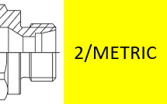

Couplings spare parts Plate spare parts
 | Housing  size | Spare  Part code
Component |  |  | Spare  Part code
Female plate | KIT TA P608 (CAP), KIT SP5 S (SAFETY LOCK)
Lever |  | -

Hou.1 |  | 1/2” |  | KIT2FNB12-2/30F
Hou.2 |  | 1/2” |  | -
Hou.3 | 1/2” |  | KIT2FNB12-2/16F
Hou.4 |  | 1/2” |  | KIT2FNB12-2/18F
Hou.5 |  | 1/2” |  | KIT2FNB12-2/18F
Hou.6 |  | 1/2” |  | KIT2FNB12-2/18F

