Multifaster 8 lines: Female plate - 8 housings 3/8". |  | Application  
MF-P5068 F-006092-F
4
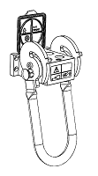 | 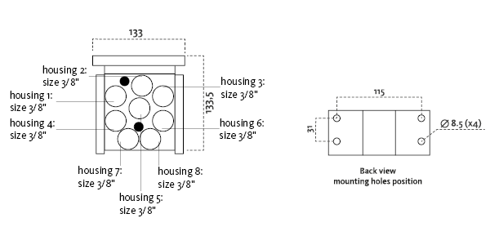
Technical Specifications
Size |  |  | Working Pressure |  | Flow Rate | Spillage | Burst pressure (MPa & psi)
dash | mm | inch | (MPa) | (psi) | (l/min) | (ml) | Male |  | Female |  | Male + Female
06 | 10 | 3/8 ‘’ | 25 | 3626 | 40 | 0,01 | 100 | 14504 | 100 | 14504 | 100 | 14504

Materials | Aluminium; Steel |  | Valve Type | Flat
Seals |  |  | Connection | Lever
Working temperatures | -25°C to 100°C  -13 F° to 212 F° |  | Disconnection | Lever
Surface treatment | CARBON STEEL (CRlll); Paint |  | Connection Under Pressure

Fixed Plate
Lever Type: "U" long lever, left safety lock
 |  |  | Housing  size |  |  | Thread  Type |  |  | Thread  Standard |  |  | Thread  size |  | Component  Type
Hou.1 | 3/8” |  |  | 16/ BSP |  |  | BSP MALE |  |  | 3/8" |  |  | Coupling
Hou.2 | 3/8” |  |  | 16/ BSP |  |  | BSP MALE |  |  | 3/8" |  |  | Coupling
Hou.3 | 3/8” |  |  | 16/ BSP |  |  | BSP MALE |  |  | 3/8" |  |  | Coupling
Hou.4 | 3/8” |  |  | 16/ BSP |  |  | BSP MALE |  |  | 3/8" |  |  | Coupling
Hou.5 | 3/8” |  |  | 16/ BSP |  |  | BSP MALE |  |  | 3/8" |  |  | Coupling
Hou.6 | 3/8” |  |  | 16/ BSP |  |  | BSP MALE |  |  | 3/8" |  |  | Coupling
Hou.7 |  | 3/8” |  |  | 16/ BSP |  |  | BSP MALE |  |  | 3/8" |  |  |  | Coupling
Hou.8 |  | 3/8” |  |  | 16/ BSP |  |  | BSP MALE |  |  | 3/8" |  |  |  | Coupling

Thread chart
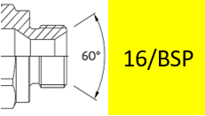

Couplings spare parts Plate spare parts
 | Housing  size | Spare  Part code
Component |  |  | Spare  Part code
Female plate | KIT VP8 (SCREWS), KIT SP4 (SAFETY LOCK)
Lever |  | KIT LP508

Hou.1 |  | 3/8” |  | KIT2FNB3816/38F
Hou.2 |  | 3/8” |  | KIT2FNB3816/38F
Hou.3 | 3/8” |  | KIT2FNB3816/38F
Hou.4 |  | 3/8” |  | KIT2FNB3816/38F
Hou.5 |  | 3/8” |  | KIT2FNB3816/38F
Hou.6 |  | 3/8” |  | KIT2FNB3816/38F
Hou.7 |  | 3/8” |  | KIT2FNB3816/38F
Hou.8 |  | 3/8” |  | KIT2FNB3816/38F

