Multifaster 5 lines: Female plate - 3 housings 1/4" - 2 housings 3/8". |  | Application  
MF-P5065 F-006071-F
4
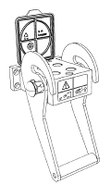 | 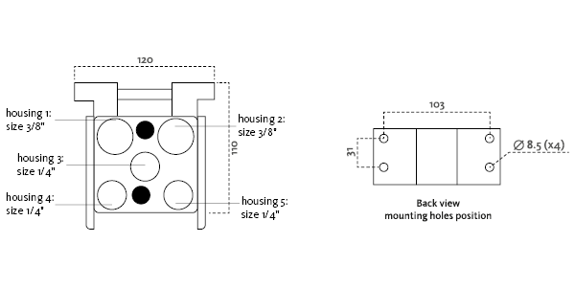
Technical Specifications
Size |  |  | Working Pressure |  | Flow Rate | Spillage | Burst pressure (MPa & psi)
dash | mm | inch | (MPa) | (psi) | (l/min) | (ml) | Male |  | Female |  | Male + Female
04 | 6.3 | 1/4 ‘’ | 25 | 3626 | 20 | 0,008 | 100 | 14504 | 100 | 14504 | 100 | 14504
06 | 10 | 3/8 ‘’ | 25 | 3626 | 40 | 0,01 | 100 | 14504 | 100 | 14504 | 100 | 14504

Materials | Aluminium; Steel |  | Valve Type | Flat
Seals |  |  | Connection | Lever
Working temperatures | -25°C to 100°C  -13 F° to 212 F° |  | Disconnection | Lever
Surface treatment | CARBON STEEL (CRlll); Paint |  | Connection Under Pressure

Fixed Plate
Lever Type: "U" lever, left safety lock, metal handle
 |  | Housing  size |  | Thread  Type |  | Thread  Standard |  | Thread  size |  | Component  Type
Hou.1 | 3/8” |  | 16/ BSP |  | BSP MALE |  | 1/2" |  | Coupling
Hou.2 | 3/8” |  | --/ BSP |  | BSP FEMALE |  | 1/2" |  | Coupling
Hou.3 | 1/4” |  | --/ BSP |  | BSP FEMALE |  | 3/8" |  | Coupling
Hou.4 | 1/4” |  | 0/ SAE |  | SAE ORB FEMALE |  | 3/8" |  | Coupling
Hou.5 | 1/4” |  | --/ BSP |  | BSP FEMALE |  | 1/4" |  | Coupling

Thread chart
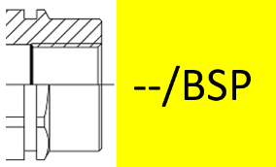 |  | 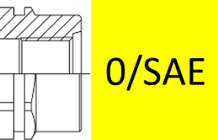
 |  |  | 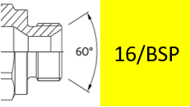

Couplings spare parts Plate spare parts
 | Housing  size | Spare  Part code
Component |  |  | Spare  Part code
Female plate | KIT VP4 (SCREWS), KIT SP5 S (SAFETY LOCK)
Lever |  | KIT LP506

Hou.1 |  | 3/8” |  | KIT2FNB3816/12G
Hou.2 |  | 3/8” |  | KIT2FNB38-12GF
Hou.3 | 1/4” |  | KIT2FNB14-38GF
Hou.4 |  | 1/4” |  | KIT2FNB14-38SF
Hou.5 |  | 1/4” |  | KIT2FNB14GAS F

