Multifaster 5 lines: Female plate - 4 housings 3/8" - 1 housing 1/2". |  | Application  
MF-P506-1 F-006057-F
4
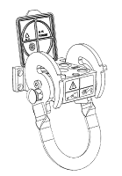 | 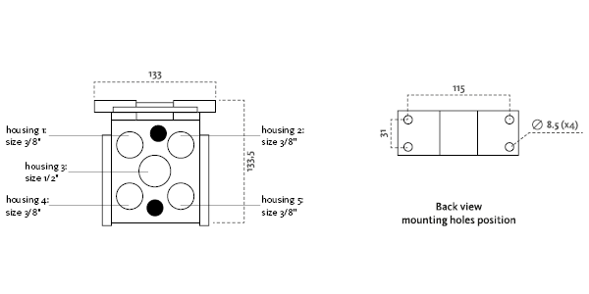
Technical Specifications
Size |  |  | Working Pressure |  | Flow Rate | Spillage | Burst pressure (MPa & psi)
dash | mm | inch | (MPa) | (psi) | (l/min) | (ml) | Male |  | Female |  | Male + Female
06 | 10 | 3/8 ‘’ | 25 | 3626 | 40 | 0,01 | 100 | 14504 | 100 | 14504 | 100 | 14504

Materials | Aluminium; Steel |  | Valve Type | Flat
Seals |  |  | Connection | Lever
Working temperatures | -25°C to 100°C  -13 F° to 212 F° |  | Disconnection | Lever
Surface treatment | CARBON STEEL (CRlll); Paint |  | Connection Under Pressure

Fixed Plate
Lever Type: "U" short lever, left safety lock
 |  | Housing  size |  | Thread  Type |  | Thread  Standard |  | Thread  size |  | Component  Type
Hou.1 | 3/8” |  | 11/ SAE |  | SAE ORFS MALE |  | 3/8" |  | Coupling
Hou.2 | 3/8” |  | 11/ SAE |  | SAE ORFS MALE |  | 3/8" |  | Coupling
Hou.3 | 1/2” |  |  |  |  |  |  |  | Electrical connector |  | 3 PINS, rated current: 13 A
Hou.4 | 3/8” |  | 11/ SAE |  | SAE ORFS MALE |  | 3/8" |  | Coupling
Hou.5 | 3/8” |  | 11/ SAE |  | SAE ORFS MALE |  | 3/8" |  | Coupling

Thread chart
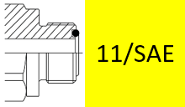

Couplings spare parts Plate spare parts
 | Housing  size | Spare  Part code
Component |  |  | Spare  Part code
Female plate | KIT VP8 (SCREWS), KIT SP5 S (SAFETY LOCK)
Lever |  | KIT LP506-1

Hou.1 |  | 3/8” |  | KIT2FNB3811/38S
Hou.2 |  | 3/8” |  | KIT2FNB3811/38S
Hou.3 | 1/2” |  | KIT SPEL08-3F
Hou.4 |  | 3/8” |  | KIT2FNB3811/38S
Hou.5 |  | 3/8” |  | KIT2FNB3811/38S

