Multifaster 4 lines: Male plate - 4 housings 1/2". |  | Application  
MF-P508 M-005851-M
4
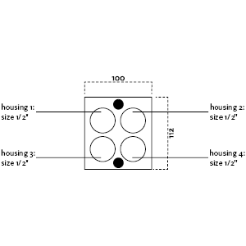

Technical Specifications
Size |  |  | Working Pressure |  | Flow Rate | Spillage | Burst pressure (MPa & psi)
dash | mm | inch | (MPa) | (psi) | (l/min) | (ml) | Male |  | Female |  | Male + Female
08 | 12,5 | 1/2 ‘’ | 20 | 2900 | MultiGrease |  | 60 | 8702 | 100 | 14504 | 60 | 8702

Technical Specifications
Size |  |  | Working Pressure |  | Flow Rate | Spillage | Burst pressure (MPa & psi)
dash | mm | inch | (MPa) | (psi) | (l/min) | (ml) | Male |  | Female |  | Male + Female
- | - | - | - | - | - | - | - | - | - | - | - | -

Materials | Aluminium; Steel |  | Valve Type | Flat
Seals |  |  | Connection | Lever
Working temperatures | -25°C to 100°C  -13 F° to 212 F° |  | Disconnection | Lever
Surface treatment | CARBON STEEL (CRlll); Paint |  | Connection Under Pressure

Mobile Plate
 |  | Housing  size |  | Thread  Type |  | Thread  Standard |  | Thread  size |  | Component  Type
Hou.1 | 1/2” |  |  |  |  |  |  |  | Plug
Hou.2 | 1/2” |  | --/ BSP |  | BSP FEMALE |  | 1/8" |  | MultiGrease
Hou.3 | 1/2” |  | --/ BSP |  | BSP FEMALE |  | 1/8" |  | MultiGrease
Hou.4 | 1/2” |  |  |  |  |  |  |  | Plug

Thread chart


Couplings spare parts Plate spare parts
 | Housing  size | Spare  Part code
Component |  | Spare  Part code
Male plate | KIT VP8 (SCREWS), KIT GP4 (PINS)

Hou.1 |  | 1/2” |  | KIT TSP 12 M
Hou.2 |  | 1/2” |  | KIT2FNP12-18GM
Hou.3 | 1/2” |  | KIT2FNP12-18GM
Hou.4 |  | 1/2” |  | KIT TSP 12 M

